Project Name : **Sathya.in**  Tested By: Kavin

Module Name : Air Conditioners

Tested On : 08/05/2019

Defect Priority : Medium

Defect Severity : Low

**Title**:

Irrelevant products are displayed.

**Steps to Reproduce:**

**Description**:

1. Open the **Sathya.in** application

2. Click on “**Home Appliances**”

3. Click on “**Air Conditioners** “option in **selection**

4. Click on “Atchya Tritya Offers” image.

**Expected Results:**

1. **Sathya.in** home page should be opened
2. **Home Appliances** should be displayed – in **selection**

1. The following item should be displayed

• Air Conditioner

o Cassette AC

o Split AC

o Window AC

• Refrigerator

o Single Door

o Double Door

o Triple Door

o Bottom Mounted

o Side By Side

• Air Cooler

• Washing Machine

o Fully Automatic

o Semi-Automatic

• Water Heater

o Instant Water Heater

o Storage Water Heater

• Kitchen Appliances

o Induction Stove

o Gas Stove

o Mixers

o Chimney

o Grinder

o HOB

o Dish Washer

o Kitchen Set

• Chest Freezer & Deep Freezer

• Stabilizer

• Water Dispenser

• Home Accessories

• Vacuum Cleaner

• Water Purifier

• Small Appliances

o Sandwich Grill

o Sandwich Maker

o Egg Boiler

o Plastic Container Set

o Coffee Maker

o Electric Kettle

o Fan

o Flask

1. Air Conditioners home page should be opened.
2. Products under “Atchya Tritya Offers” should be displayed.

**Actual Results:**

1. **Sathya.in** home page opened
2. **Home Appliances** are displayed – in **selection**

1. The following item displayed

• Air Conditioner

o Cassette AC

o Split AC

o Window AC

• Refrigerator

o Single Door

o Double Door

o Triple Door

o Bottom Mounted

o Side By Side

• Air Cooler

• Washing Machine

o Fully Automatic

o Semi-Automatic

• Water Heater

o Instant Water Heater

o Storage Water Heater

• Kitchen Appliances

o Induction Stove

o Gas Stove

o Mixers

o Chimney

o Grinder

o HOB

o Dish Washer

o Kitchen Set

• Chest Freezer & Deep Freezer

• Stabilizer

• Water Dispenser

• Home Accessories

• Vacuum Cleaner

• Water Purifier

• Small Appliances

o Sandwich Grill

o Sandwich Maker

o Egg Boiler

o Plastic Container Set

o Coffee Maker

o Electric Kettle

o Fan

o Flask

1. Air Conditioners home page opened.
2. Products under “Atchya Tritya Offers” and offers not applicable products also displayed.

**Screen Shot For Defect**:

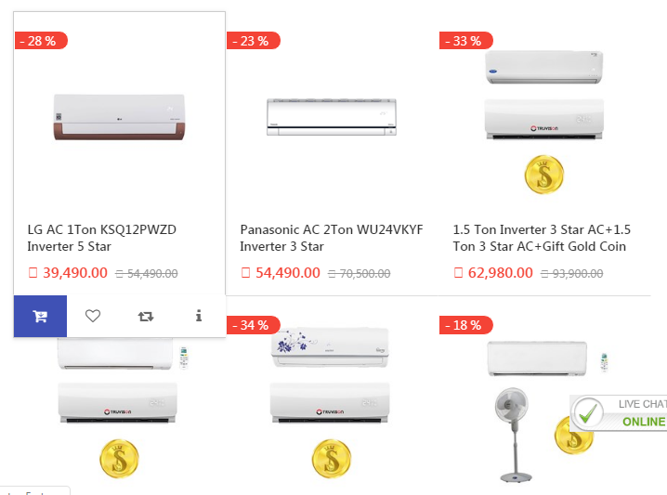

Project Name: **SATHYA Web Page**  Tested By: Sivanesan N

Module Name: Home Page and Washing Machine

Tested On : 08/05/2019

Defect Priority: High

Defect Severity: High

**Title**:

To enter Phone number in online ticket Registration page

**Steps to Reproduce:**

**Description**:

1) Click on the "LIVE CHAT Online" Hyper link .

2) Enter the details for online ticket registration for product issue.

3) Click on the "Phone Number” Text filed

4) Enter Alphabet and special characters text in "phone number” text filed

5) Click on the "Submit" button

6) Click on the "-product- Drop down box"

7) Select "-product-" as mentioned Drop Down box

8) Click on the "Submit "Button

**Expected Results:**

Online ticket registration page should be able to write the text fields with following details  
  
 Display Name  
 Email Id  
 Phone number  
 Product  
 Service call id  
 Subject

**Actual Results:**

* Online ticket registration page IS able to write the text fields with following details  
    
    
   Display Name  
   Email Id  
   Phone number  
   Product  
   Service call id  
   Subject  
  + Enter Place
  + Enter Pin number
* After filled all values correctly then click SUBMIT button
* After submit button clicked registration done message will appear

**Screenshot for defect**

**Before value enter**

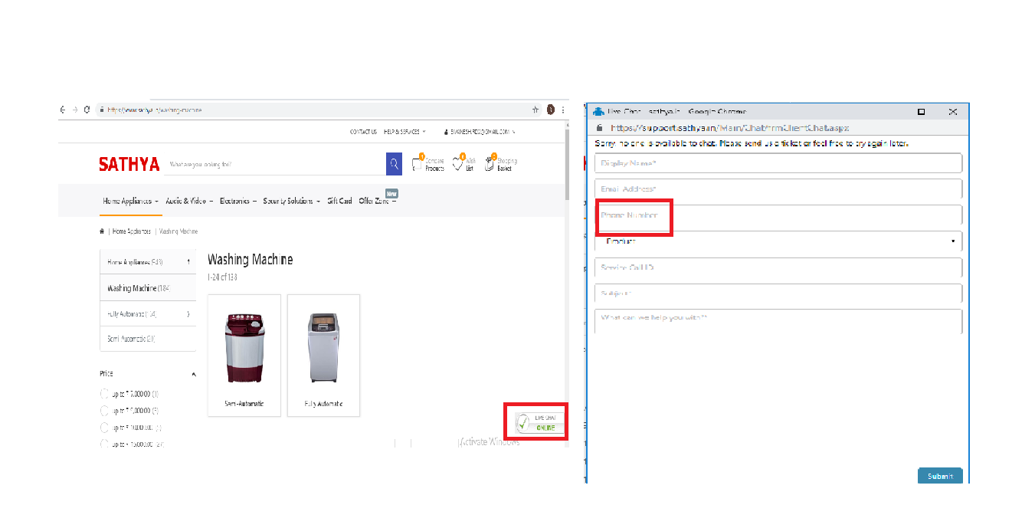

**After value enter**

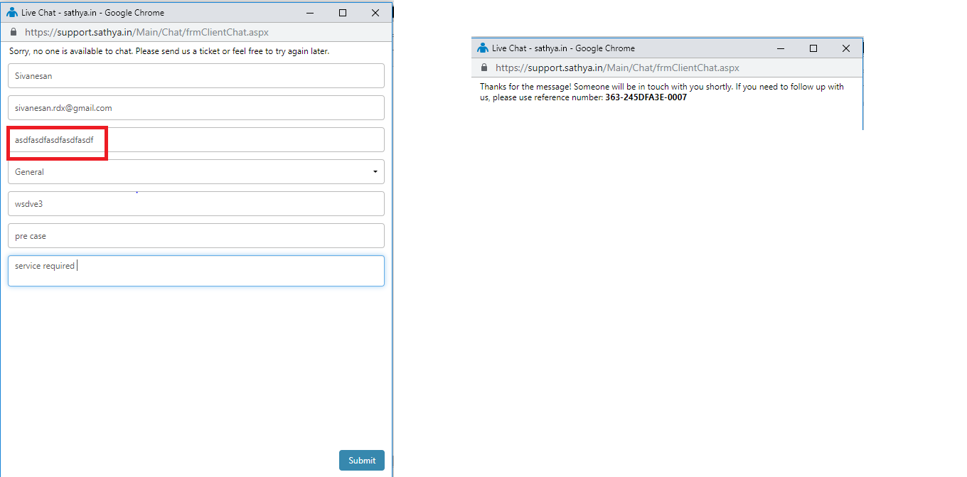

Project Name: **SATHYA Web Page**  Tested By: Sivanesan N

Module Name: Home Page and Washing Machine

Tested On : 08/05/2019

Defect Priority: High

Defect Severity: Medium

**Title**:

Pop up message is not displaying the minimum quantity.

**Steps to Reproduce:**

**Description**:

1. Click on “Semi-Automatic" hyper link under Washing Machine page

2. Click the product image

3) Click "Add to Cart" button

4) Click on "Product quantity" to edit the quantity

5) enter the "product quantity”

Is 0

6) Click on "Go to cart” button

**Expected Results:**

The "Cart" page should be displayed with three sections

a. Shopping Cart

i. Product Image

ii. Product Name

iii. Product Quantity

iv. Move to Wish list

v. Subtotal

vi. Remove

vii. "Go to cart” button

viii. "Check out" button

Product quantity value should be 0

.Shopping card page should be displayed & it should displayed the error pop up message”

The minimum quantity allowed for purchase is 1"

**Actual Results:**

The "Cart" page is displayed with three sections

a. Shopping Cart

i. Product Image

ii. Product Name

iii. Product Quantity

iv. Move to Wish list

v. Subtotal

vi. Remove

vii. "Go to cart” button

viii. "Check out" button

5) Product quantity value is 0

6).Shopping cart page is displayed & it is displayed message “your cart is empty"

**Screenshot for defect**

**Before value enter**

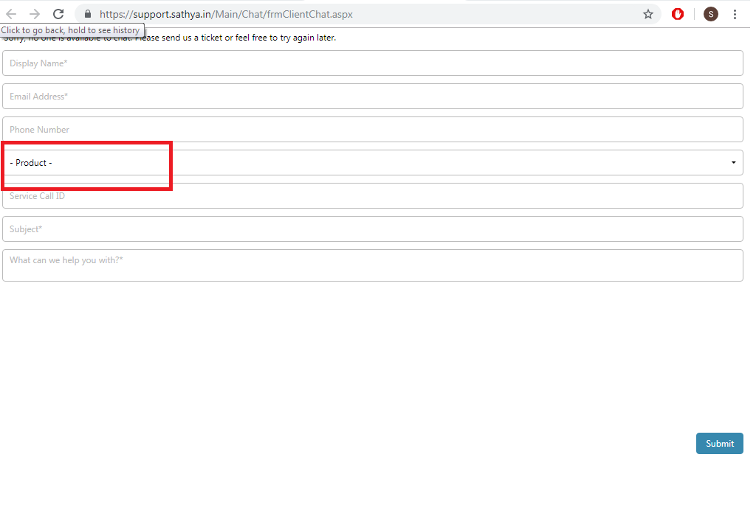

**After value enter**

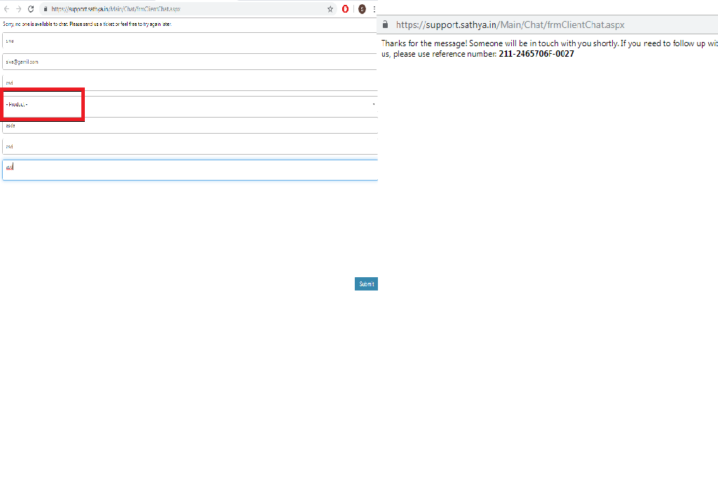

Project Name : **SATHYA.IN**  Tested By: MOHAMEDBASHA

Module Name : LOGIN PAGE

Tested On : 08/05/19

Defect Priority : MEDIUM

Defect Severity : MEDIUM

**Title**:

Phone number field accept the characters

**Steps to Reproduce:**

**Description**:

1.Open the **SATHYA.IN** application

2.Click on “**LOGIN**” option

3.Click on “**REGISTER**” option

3.Fill the details in the “**Registration**” page

4. Enter the “**CHARACTERS”** in the “**PHONE**” information field

5.Click the “**REGISTER**” icon

**Expected Results:**

1. **SATHYA.IN**  Home page should be opened .The application page should be displayed with the following details

>**Application name should be displayed top left corner**

**> Text field to search product with search icon**

**> Compare product icon**

**> Wish list**

**> Shopping basket**

**> Gift card**

**> Featured products**

**> Top brands**

**> Social links**

**> Information**

**> Service**

**> Company details**

**> Newsletters**

**> Login**

**> Contact us**

Drop down menu should be opened with the following options

>**Home appliances**

**> Audio &video**

**> Electronics**

**> Security solutions**

**> Offer zone**

**> Help services**

1. Click on “**LOGIN**” option
2. “**REGISTERATION**” Page should be displayed
3. Entered “**CHARACTERS”** in the “**PHONE**” information field should be displayed.
4. Clicked on the “**REGISTER**” icon. The application should not accept characters in the phone field

**Actual Results:**

1. **SATHYA.IN**  Home page s opened .The application page displayed with the following details

>**Application name should be displayed top left corner**

**> Text field to search product with search icon**

**> Compare product icon**

**> Wish list**

**> Shopping basket**

**> Gift card**

**> Featured products**

**> Top brands**

**> Social links**

**> Information**

**> Service**

**> Company details**

**> Newsletters**

**> Login**

**> Contact us**

Drop down menu should be opened with the following options

>**Home appliances**

**> Audio &video**

**> Electronics**

**> Security solutions**

**> Offer zone**

**> Help services**

1. Clicked on “**LOGIN**” option
2. “**REGISTERATION**” Page displayed
3. Entered “**CHARACTERS”** in the “**PHONE**” information field displayed.
4. Clicked on the “**REGISTER**” icon. The application accept characters in the phone field

**Output display**: 1. **FILLING THE DETAILS IN REGISTERATION PAGE**

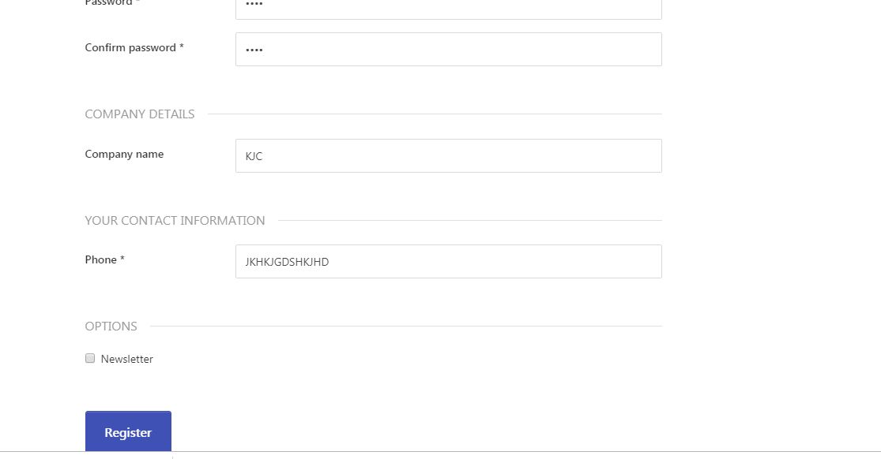

**OUTPUT DISPLAY 2:**

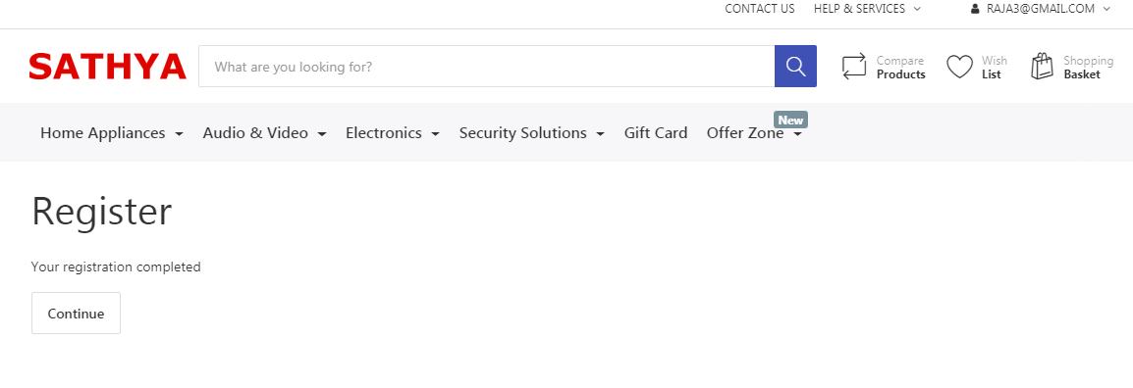

Project Name: **Sathya E-Commerce webpage application**  Tested By**:** Kavinkumar

Module Name:  **Audio & Video**

Tested On : 08.05.2019

Defect Priority: Medium

Defect Severity: Low

**Title**:

“No search result found message” not displayed while searching Invalid Brand name on Find Brand search bar.

**Steps to Reproduce:**

**Description:**

1. Open <https://www.sathya.in/>
2. Mouse hover on “Audio and Video” drop down on home page and Click on “LED Television”
3. Click on Brand tab available on the left side of LED Television page.
4. Enter Invalid Brand name on Find Brand search bar.

**Expected Results:**

1. Application home page should be opened
2. “LED television” should be displayed with following item on left side of LED television page.

* LED Television

HD Ready

Full HD

Ultra HD

* Price
* Availability
* Brand
* Android Operating system
* Screen Size
* Display Type
* Television Type

1. Available Brands should be displayed.
2. “No search result found” message should be displayed.

**Actual Results:**

1. Application home page opened.
2. “LED television”displayed with following item.

* LED Television

HD Ready

Full HD

Ultra HD

* Price
* Availability
* Brand
* Android Operating system
* Screen Size
* Display Type
* Television Type

1. Available Brands displayed
2. “No search result found” message not displayed

**Screen for defect:**

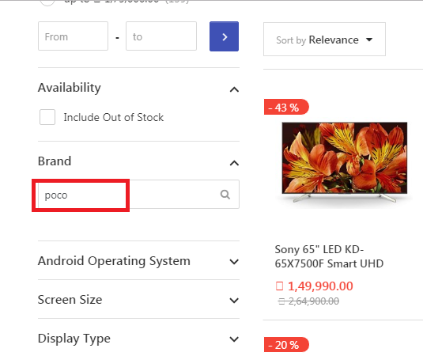

Project Name: **SATHYA.IN**  Tested By**: MAHENDRAN R**

Module Name:  **Water Purifier**

Tested On : 08/05/2019

Defect Priority: Low

Defect Severity: Low

**Title**: “No search result found” error message not displayed.

**Steps to Reproduce:**

**Description:**

1. Open application URL
2. Mouse hovers on “Home Appliances” dropdown on home page and click on “**Water Purifier”.**
3. Click on Water Purifier Capacity tab available on the left side of **Water Purifier** search tab**.**
4. Enter the invalid Water Purifier Capacity on find Water Purifier Capacity.

**Expected Results:**

1. Sathya.in home page should be opened.
2. “Water Purifier” page should be displayed.
3. Water Purifier Capacity should be displayed following Water Purifier Capacity details:

* 4.2 Litres
* 6 Litres
* 7 Litres
* 8 Litres
* 9 Litres
* 10 Litres
* 14 Litres
* 23 Litres

1. Enter invalid Water Purifier Capacity “No search result found” error message should be displayed.

**Actual Results:**

1. Sathya.in home page should be opened.
2. “Water Purifier” page should be displayed.
3. Water Purifier Capacity should be displayed following Water Purifier Capacity details:

* 4.2 Litres
* 6 Litres
* 7 Litres
* 8 Litres
* 9 Litres
* 10 Litres
* 14 Litres
* 23 Litres

4. Enter invalid Water Purifier Capacity “No search result found” error message not displayed.

**Screenshot for defect:**

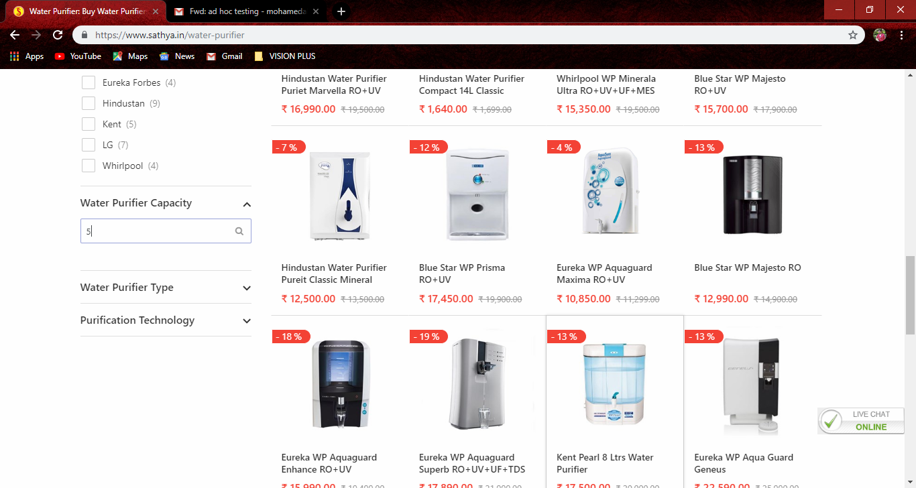

Project Name : **Sathya.in**  Tested By: Balamurugan

Module Name : Kitchen Appliances

Tested On : 08/05/2019

Defect Priority : Medium

Defect Severity : Medium

**Title**:

Un subscription is accepting even though not subscribed.

**Steps to Reproduce:**

**Description**:

1. Open the **Sathya.in** application

2. Navigate to Footer section

3.Navigate to Subscription section

**Expected Result:**

1.Enter new email(not subscribed) id in the text filed, it should throw an error message

**Actual Result:**

1.When we enter new email(not subscribed) id in the text field, it throwing accepted message

**Screen Shot For Defect**:



Project Name: **SATHYA.in**  Tested By**: Srikanth.M**

Module Name:  **HOME THEATRE**

Tested On : 08.05.2019

Defect Priority: High

Defect Severity: High

**Title**: Add To Cart option is not available

.

**Steps to Reproduce:**

**Description:**

1. Open https://www.sathya.in
2. Click on to Audio & Video Tab
3. Click on to Home Theatre Tab
4. Click the Image & Add to Cart

**Expected Results:**

Step 1:

1. Sathya homepage should be opened.
2. Click on to Audio and Video Tab
3. Click on to Home Theatre Tab, the home theatre page will be opened
4. Click on to image to buy the item
5. The following details should be opened

* Add to Cart
* Add to List
* Compare
* Questions
* Email a friend

Step 2:

1. Sathya homepage should be opened.
2. Click on to search box and give the single alphabet in between a-z in the search text box
3. The search box should search the items according to the given input
4. The search box should search the single alphabet

**Actual Results:**

Step 1 :

1. Sathya homepage should be opened.
2. Click on to Audio and Video Tab
3. Click on to Home Theatre Tab, the home theatre page will be opened
4. Click on to image to buy the item
5. The following details will not displayed

* Add to Cart
* Add o List
* Compare
* Questions
* Email a friend

Step 2 :

1. Sathya homepage should be opened.
2. Click on to search box and give the single alphabet in between a-z in the search text box
3. The search box should search the items according to the given input
4. The search box will not search the single alphabet

**Screenshot for Defect :**

